Artificial Intelligence  
Lab Exercise 9  
Deep Learning Implementation

short line

Ashwin Prakash  
RA1911026010048

**Aim:**

To implement a Deep Learning Algorithm

**Problem Statement:**

To implement a Deep Learning algorithm on a real-life dataset

**Algorithm:**

1. Install the necessary packages.
2. Fetch the CIFAR-10 dataset and split it into train and test dataset
3. Build the Convolutional Neural Network model consisting of:
4. Input layer containing the training dataset
5. 3 Convolutional Layers with 32, 64 and 128 nodes respectively with *ReLU* activation function.
6. Flatten layer to flatten the output received from the convolutional layers and further feed it to the next layer
7. A Dense layer initialized with 1024 nodes with an activation function of *ReLU*
8. A Dropout layer which drops 20% of nodes from the previous layer to prevent overfitting.
9. Final Dense Layer to map the training examples to their output using *Softmax* function.
10. Compile and train the model.
11. Test the model against the validation data and compare the results.

**Program:**

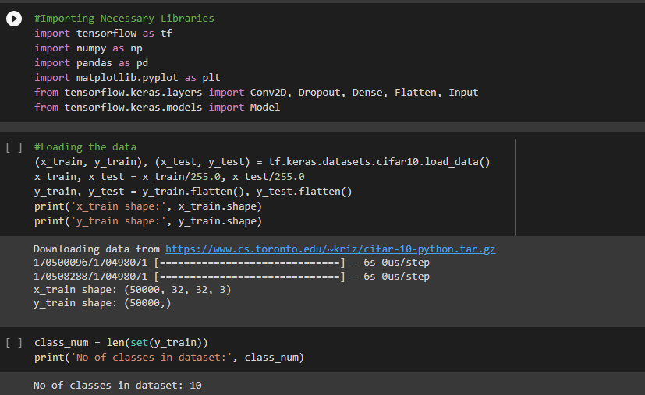

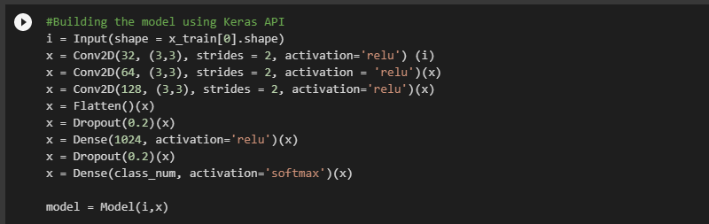

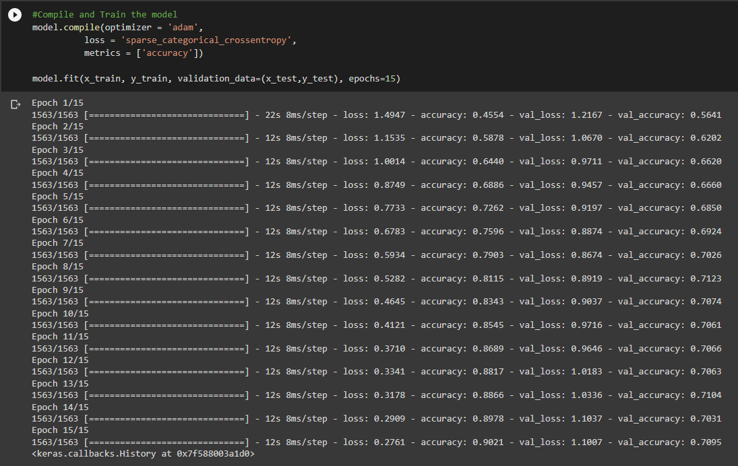

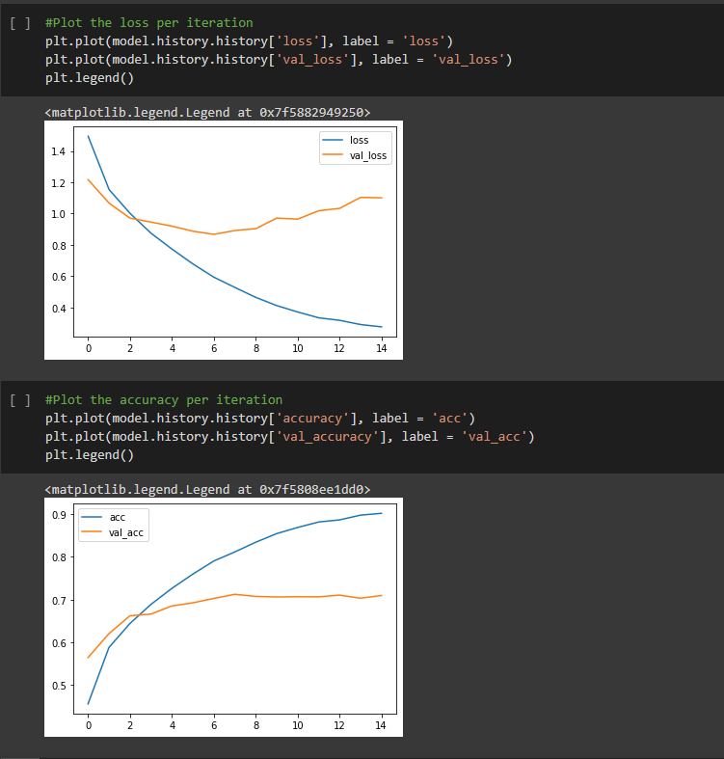

**Output:**

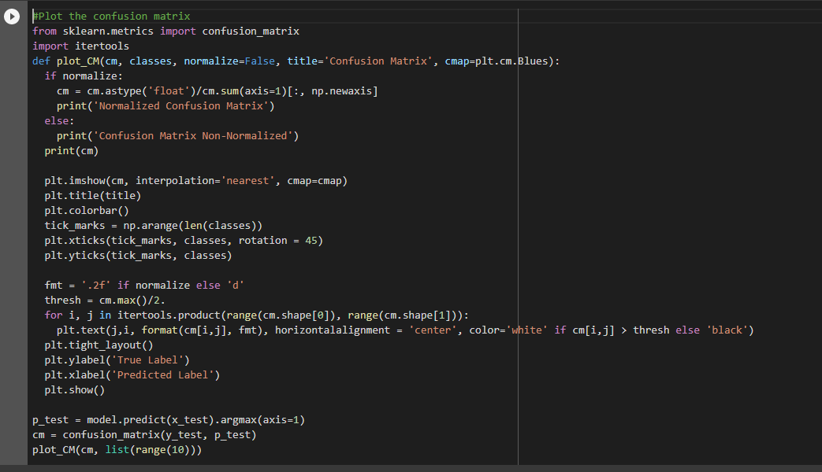

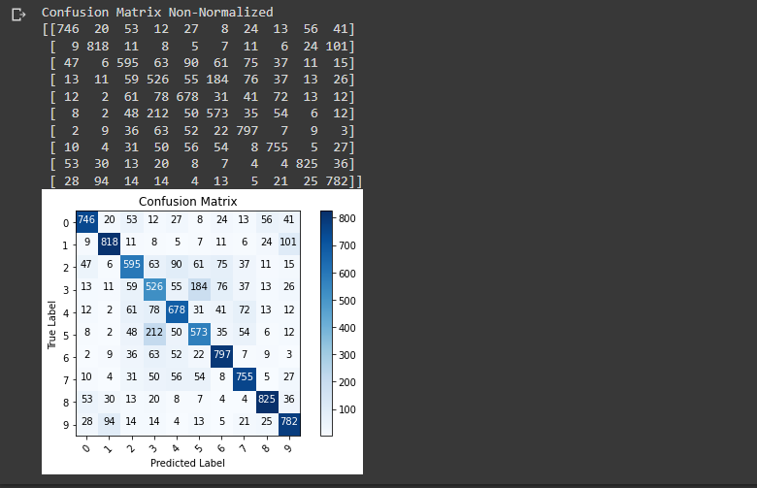

**Observations:**

1. From the Loss per iteration graph, we find that the loss decreases consistently for the training data but for the testing data, it drops to a certain point and then remains constant.
2. From the accuracy per iteration graph, we find that the accuracy increases steadily for training data but it reaches upto a point and then remains constant for the testing data.
3. From the above two observations and the confusion matrix given, we can infer that the model has overfitted on the training data thus giving poor performance on the test data. We can further increase the accuracy of the test data by data augmentation techniques, thus resulting in more data for the algorithm to learn and thus giving a better accuracy.

**Inference:**

The Deep Learning Algorithm has been successfully implemented on a real-life usecase.

**Result:**

Deep Learning Implementation problem is implemented successfully.